DSCI 5350 SQOOP Activity-2 Buddha Satyasriharsha

Importing only the table structure to Hive

1.Open the terminal and run the following script provided to ensure all services are running  
2.Type hive and press Enter to get to the hive prompt  
3.Run the show tables; command to verify that there are no tables at the root level in Hive

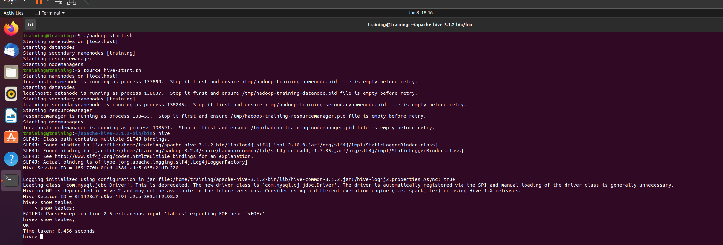

4. Use the create-hive-table tool to import the table (structure) to Hive  
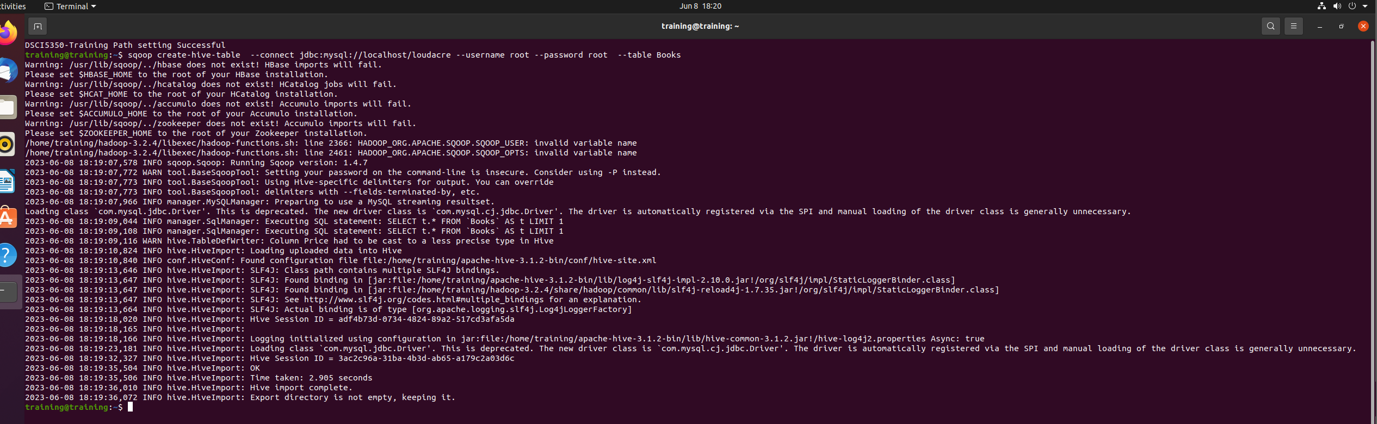

5.Check the creation of this table in the Hive terminal  
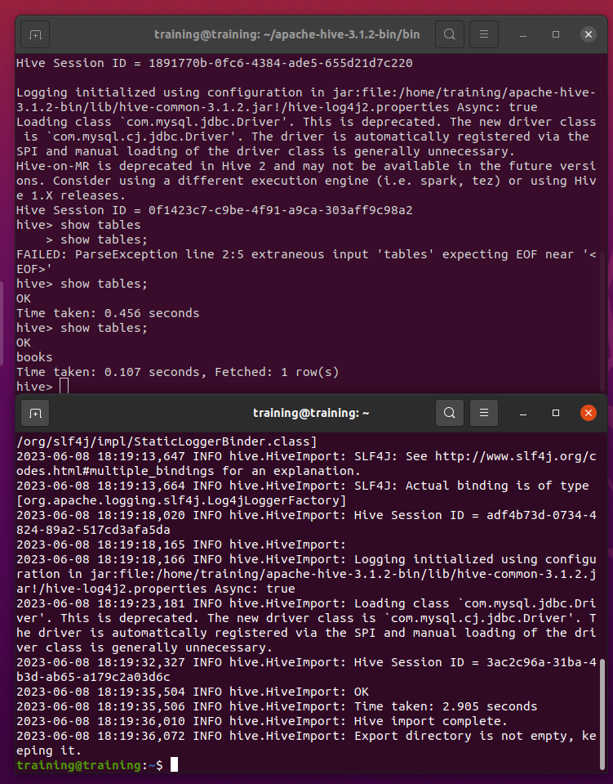

6.Check whether this table has any records?

7.Check the definition of the table using the following command:  
8.Validate the datatypes for the table in MySQL and compare it to the data types in Hive  
  
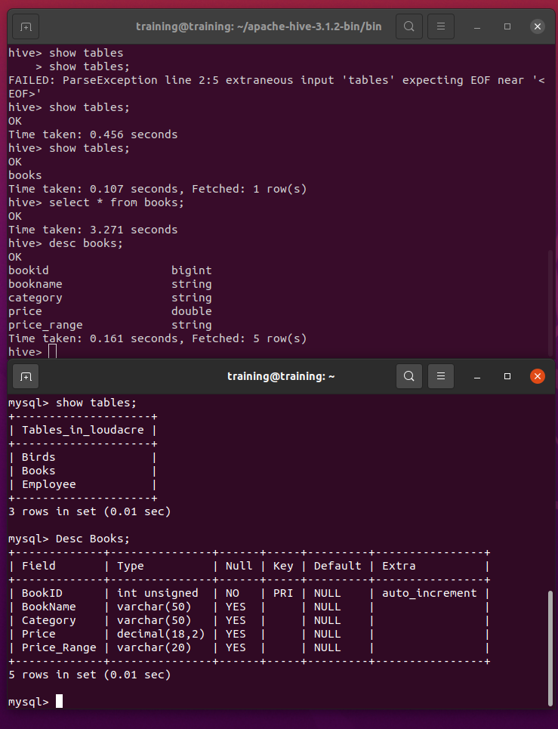

Importing table Structure with data to Hive  
1.Type the following command on the terminal

2.Go to your Hive terminal and validate the table is created and has records  
show tables  
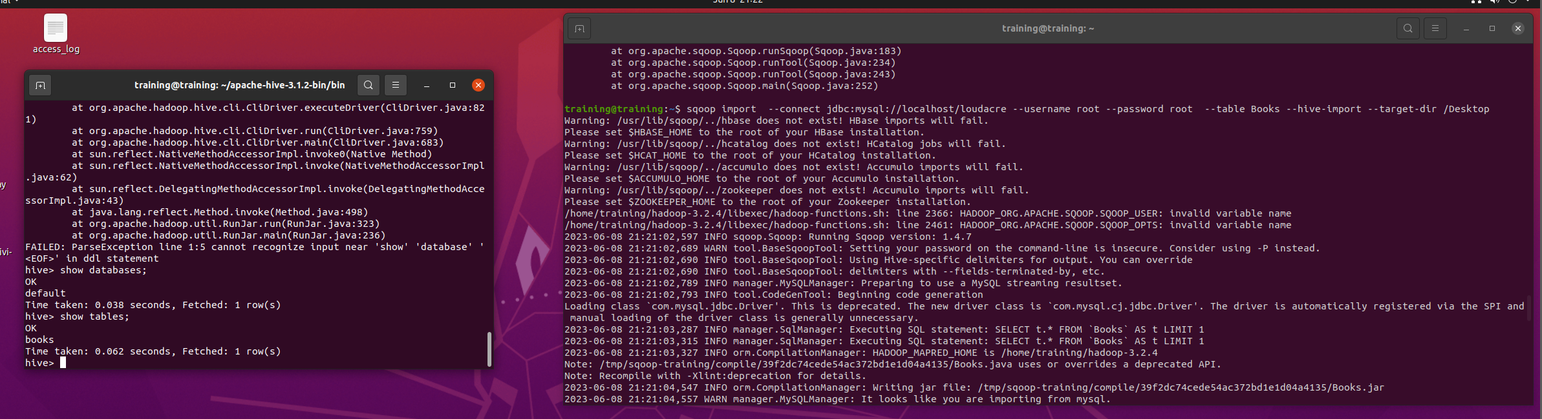

Select \* from books;

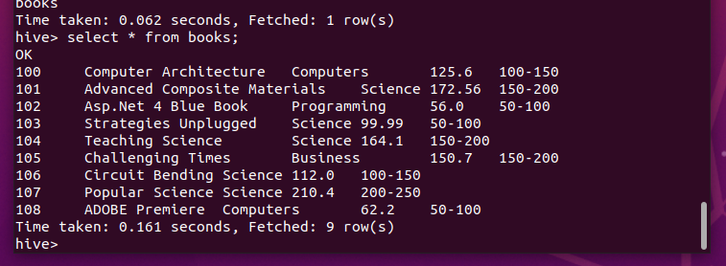

3.Validate that all records from MySQL were imported  
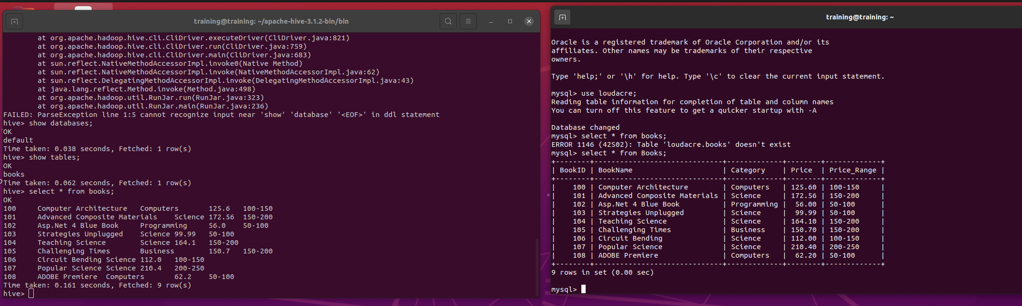

4. Go to HDFS file browser localhost:9870/, and browse to the folder

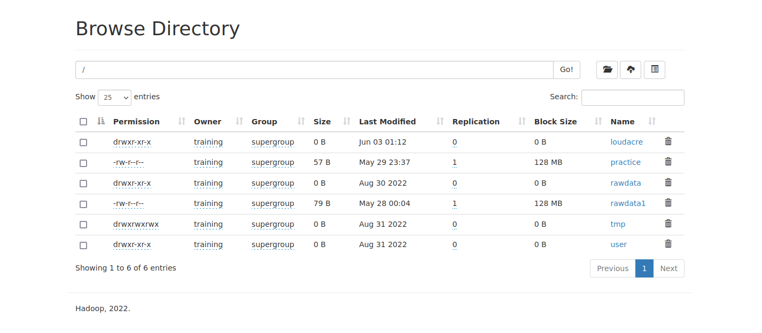

Fine Tuning our Table Import to Hive

2.Drop the books table created in the previous activity.  
drop table books;  
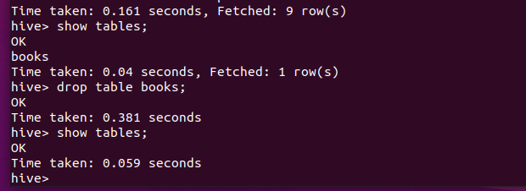

3. Use the following command to create the table:

4.Validate the creation and loading of the table in Hive  
  
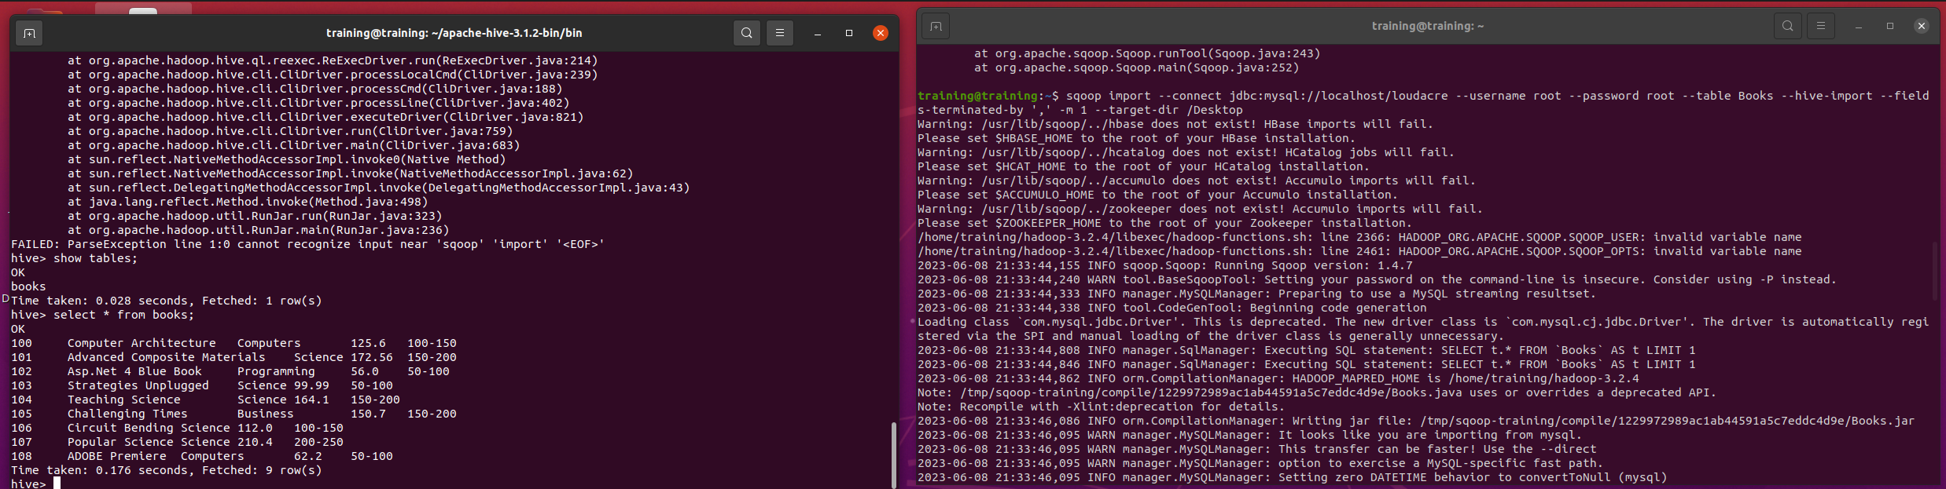  
  
5.Go to HDFS file browser to check the files that are created as the result of this import in Hive

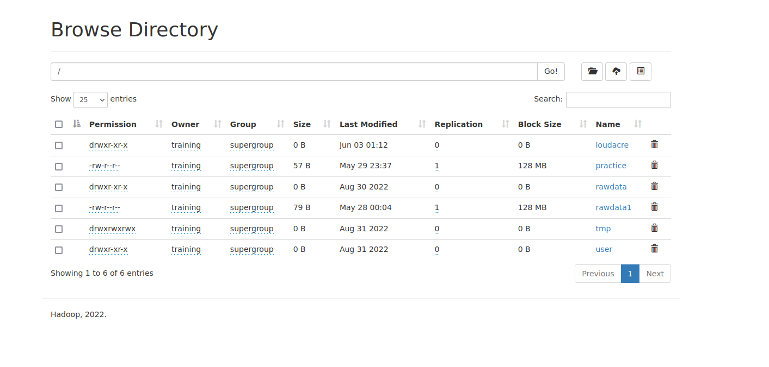

Exporting Data Using Sqoop  
1.First off, describe your Hive table to identify the datatypes.

2.Run a query in Hive to see the data and determine the data length of columns for the  
MySQL table  
3.SQL

4.use loudacre;

5. Create table command to create table for exporting data to.  
6. Validate the creation of the table

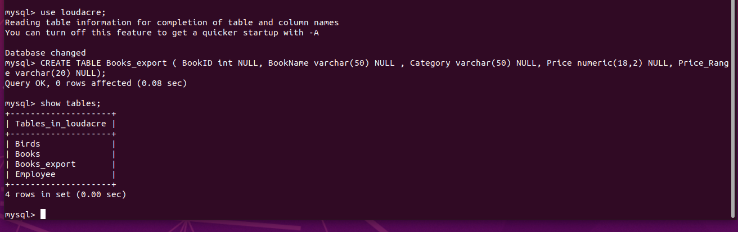

Using Sqoop to Export the Data  
7.Open a new terminal and type the following command. Make sure that the file to be  
exported is saved as comma delimited before running the command.  
  
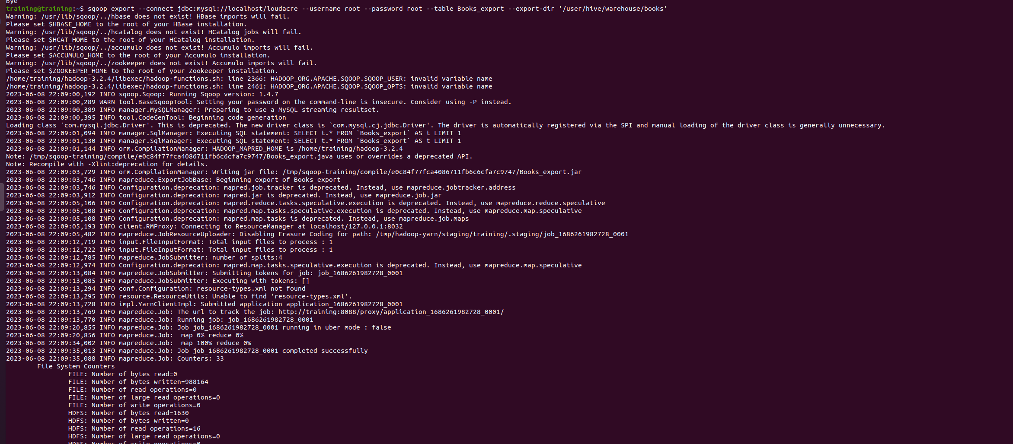

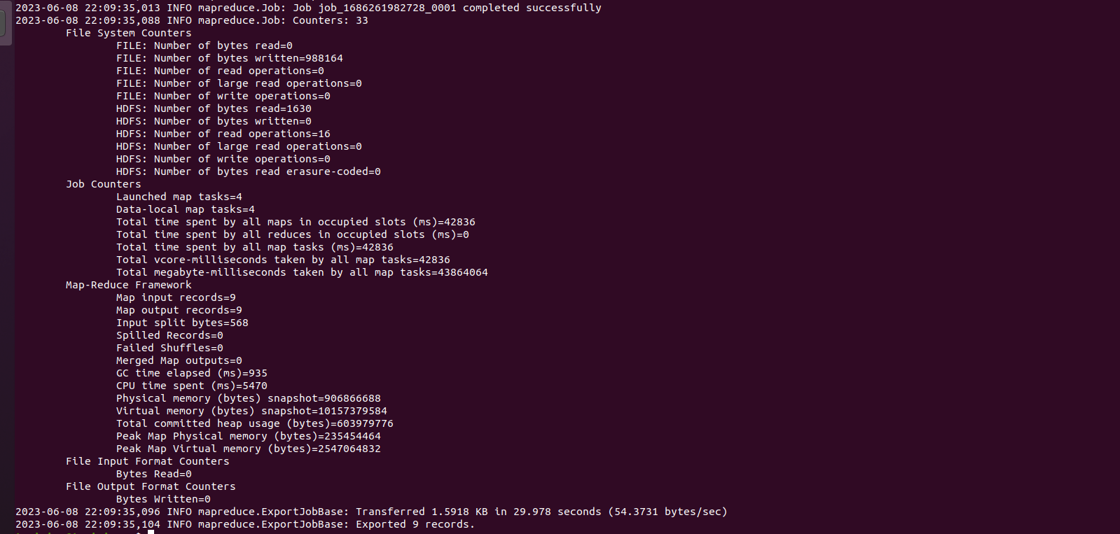

8. Validate the results in MySQL database  
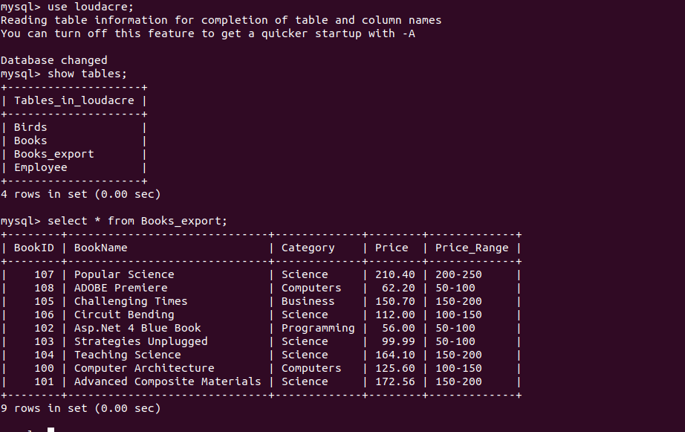

Tasks: Import Employee table from Loudacre database in MySQL to Hive using ‘|’ as a  
delimiter. Export the table to MySQL. Use your user-id as the suffix in the table name in  
MySQL to ensure that it does not get confused with the original table

